General Welfare Requirement: Organisation
Providers must plan and organise their systems to ensure that every child receives an enjoyable and challenging learning and development experience that is tailored to meet their individual needs.
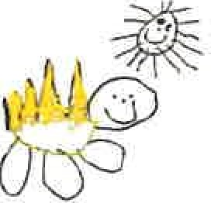
Gorran Pre School
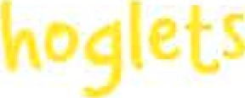
Partnership

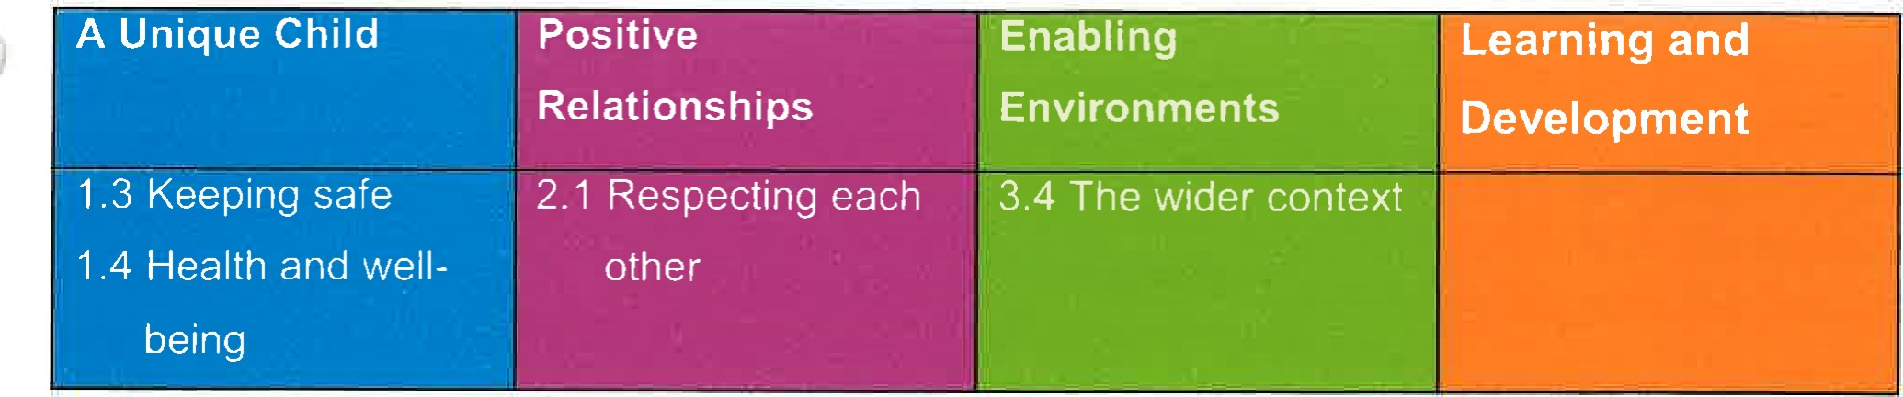
4.7 Working in partnership with other agencies
Policy Statement
At Gorran Pre-School Hoglets we work in partnership with local and national agencies to promote the well-being of all children.
EYFS Key themes and commitments
Procedures
We work in partnership or in tandem with, local and national agencies to promote the wellbeing of children.
Procedures are in place for sharing of information about children and families with other agencies. These are set out in the Information Sharing Protocol, Safeguarding Children procedures and the Special Educational Needs Procedures.
Information shared by other agencies with us is regarded as third party information. This is also kept in confidence and not shared without consent from that agency.
When working in partnership with staff from other agencies, we make those individuals welcome in the setting and their professional roles are respected.
- We follow the protocols for working with agencies, for example on child protection.
- Staff from other agencies do not have unsupervised access to the child they are visiting in the setting and do not have access to any other child(ren) during their visit.
Our staff do not casually share information or seek informal advice about any named child/family.
When necessary we consult with local and national agencies who offer a wealth of advice and information that help us develop understanding of issues facing us and who can provide support and information for parents. For example, ethnic/cultural organisations, drug/alcohol agencies, welfare rights advisors or organisations promoting childcare and education, or adult education.
We share information to other settings that children also attend.

This policy was adopted at a meeting of
Held on
Date to be reviewed
Signed on behalf of the management committee
Name of signatory
Role of signatory (e.g. chair)
Gorran Pre-School Hoglets name of setting 30 September 2015 (date) 30 September 2016 (date)

Michelle Beard

Michelle Beard

Pre-School Leader/Nominated Person

General Welfare Requirement: Organisation
Providers must plan and organise their systems to ensure that every child receives an enjoyable and challenging learning and development experience that is tailored to meet their individual needs.
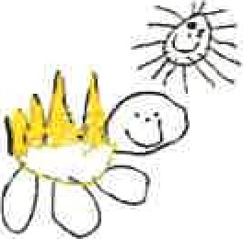
A Unique Child | Positive  Relationships | Enabling  Environments | Learning and  Development
1 .3 Keeping safe  1 .4 Health and well-  being | 2.1 Respecting each  other | 3.4 The wider context
Gorran Pre School
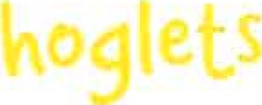
Partnership

4.7 Working in partnership with other agencies
Policy Statement
At Gorran Pre-School Hoglets we work in partnership with local and national agencies to promote the well-being of all children.
EYFS Key themes and commitments
Procedures
We work in partnership or in tandem with, local and national agencies to promote the wellbeing of children.
Procedures are in place for sharing of information about children and families with other agencies. These are set out in the Information Sharing Protocol, Safeguarding Children procedures and the Special Educational Needs Procedures.
- Information shared by other agencies with us is regarded as third party information. This is also kept in confidence and not shared without consent from that agency.
- When working in partnership with staff from other agencies, we make those individuals welcome in the setting and their professional roles are respected.
- We follow the protocols for working with agencies, for example on child protection.
Staff from other agencies do not have unsupervised access to the child they are visiting in the setting and do not have access to any other child(ren) during their visit.
Our staff do not casually share information or seek informal advice about any named child/family.
When necessary we consult with local and national agencies who offer a wealth of advice and information that help us develop understanding of issues facing us and who can provide support and information for parents. For example, ethnic/cultural organisations, drug/alcohol agencies, welfare rights advisors or organisations promoting childcare and education, or adult education.
We share information to other settings that children also attend.

This policy was adopted at a meeting of: Gorran Preschool Hoglets
Held on: October 2019
Date to be reviewed: October 2020
Name of signatory
Role of signatory (e.g. chair)

Michelle Beard
Michelle Beard

Pre-School Leader/Nominated Person

